For GSD customers being billed with power factor whose meter have been replaced with an AMI meter, the power factor will no longer be read. The power factor will be calculated using the KWH and KVARH index reads.

If the KVARH meter read is missing, the system will be unable to bill the account.

This job aid documents the steps needed to estimate the KVARH consumption.

From the SAP menu execute transaction ES32 to display the installation.
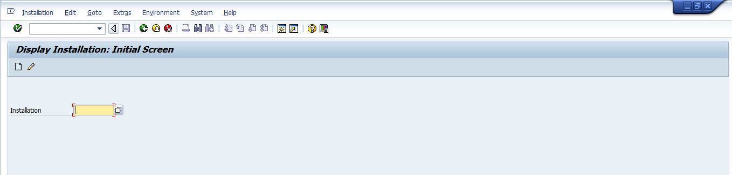
Enter the installation number and hit Enter.

Display the Billing View
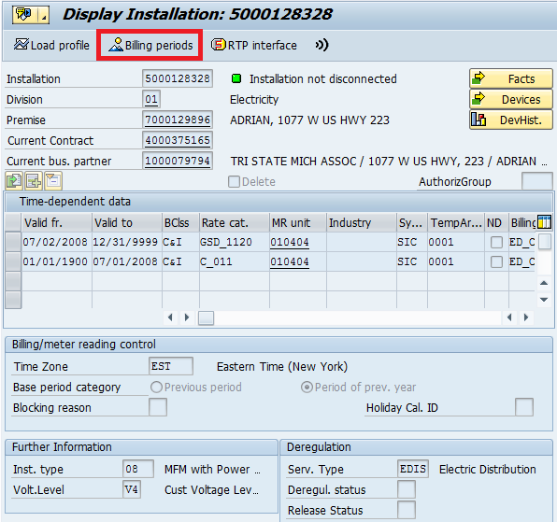
Click on the Billing periods button to display the Billing View

Click on the MT date tab to display the Meter Reading
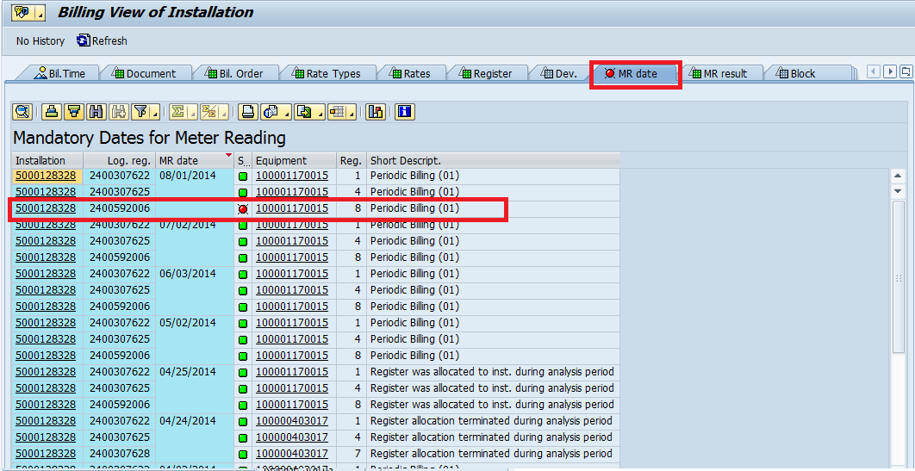
If the MR date is not sorted, sort it in descenting order.
A red traffic light signifies either missing read or implausible read. Note the MR date and register number.

Go to the Meter Reading Results by clicking on the MR result tab
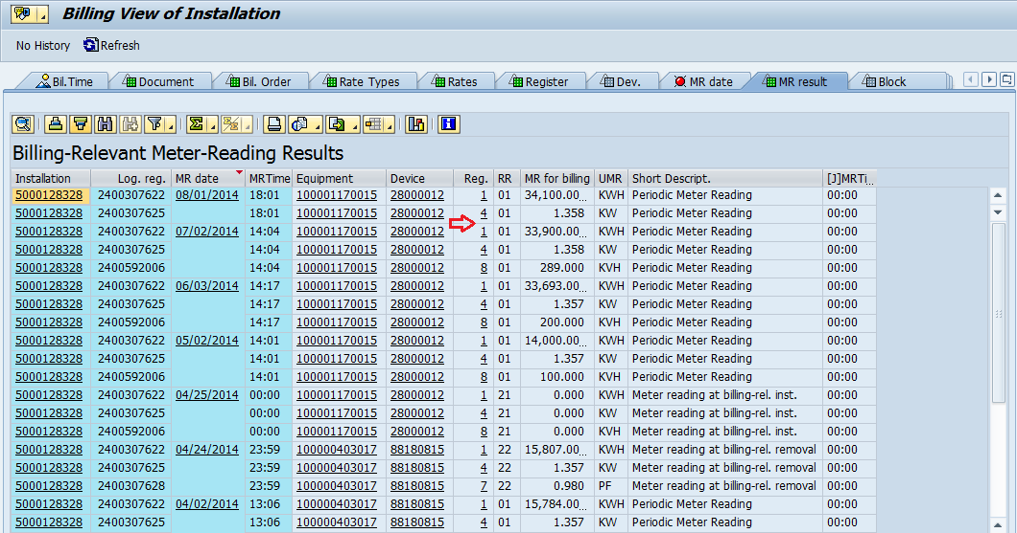
If the MR date is not sorted, sort it in descenting order.
Check the entry for the MR date and register number noted in the previous step. If no entry exist then the KVARH read is missing.

From the SAP menu execute transaction EL28 to enter a meter read.
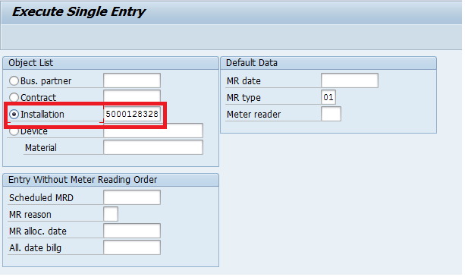
Populate the Installation number, then click Enter.
Note that you can also enter any object in the Object List subscreen. This will take you to the Meter Reading Results Entry screen.

The Single Entry screen will be displayed if you are only missing read for one date. If you are missing reads for multiple dates, you must first select the read date you want to process, then the Single Entry screen will be displayed.
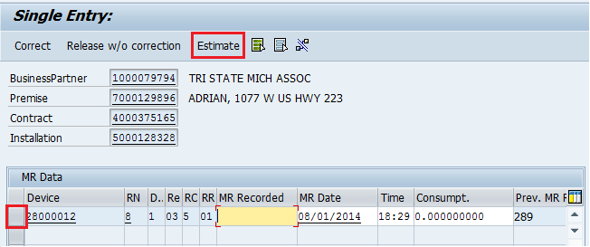
In the screen above, only the KVARH read is missing. To estimate, click on the Estimate button.
If you need to estimate the read for multiple registers, you will need to click the item first before clicking the Estimate button.

Once estimated, the MR Recorded will be populated, and the Consumpt. Will be calculated.
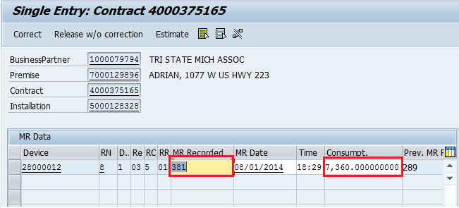
Click on the Save icon to save your estimate.

